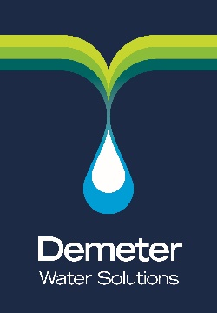
Quality Policy

Demeter Limited

Demeter Limited provides services to the public and private sector to assist customers to better manage their utility networks and reduce costs.

It is our objective to provide works to a consistently high standard and to ensure a continued level of support and service to customers resulting in high levels of customer satisfaction.

In order to achieve these objectives, we seek to;

- Ensure sound and robust procedures are documented and implemented so that all relevant information is recorded, retrievable and stored in a secure manner.

- Provide clear and comprehensive information to customers

- Continually improve the levels of service we provide

- Obtain objective customer feedback to monitor satisfaction levels and provide opportunities to review and improve our service

- Train and communicate with staff to ensure these objectives are met

It is our intention to maintain compliance with ISO 9001 Quality Management standard, which we were pleased to be awarded in December 2017.

Signed: Position : Date:

A.Smedley Director October 1st 2018

